**Use sorting and searching algorithms to solve given problem scenario**

Write an application to store ‘N’ numbers of type integers and sort it using below explained logic (Bubble sort). Your program should display the sorted numbers in a formatted way

Example: Let us take the array of numbers "5 1 4 2 8", and sort the array from lowest number to greatest number using bubble sort. In each step, elements written in bold are being compared. Three passes will be required.

First Pass:

( 5 1 4 2 8 ) ( 1 5 4 2 8 ), Here, algorithm compares the first two elements, and swaps since 5 > 1. ( 1 5 4 2 8 ) ( 1 4 5 2 8 ), Swap since 5 > 4



( 1 4 5 2 8 ) ( 1 4 2 5 8 ), Swap since 5 > 2

( 1 4 2 5 8 ) ( 1 4 2 5 8 ), Now, since these elements are already in order (8 > 5), algorithm does not swap them.

Second Pass:

( 1 4 2 5 8 ) ( 1 4 2 5 8 )



( 1 4 2 5 8 ) ( 1 2 4 5 8 ), Swap since 4 > 2

( 1 2 4 5 8 ) ( 1 2 4 5 8 )

( 1 2 4 5 8 ) ( 1 2 4 5 8 )

Now, the array is already sorted, but our algorithm does not know if it is completed. The algorithm needs one whole pass without any swap to know it is sorted.

Third Pass:

( 1 2 4 5 8 ) ( 1 2 4 5 8 )



( 1 2 4 5 8 ) ( 1 2 4 5 8 )

( 1 2 4 5 8 ) ( 1 2 4 5 8 )

( 1 2 4 5 8 ) ( 1 2 4 5 8 )



**Use sorting and searching algorithms to solve given problem scenario**

Write a method which accepts an integer array and key element to search. It should return ‘true’ if given key element found otherwise ‘false’



**Use sorting and searching algorithms to solve given problem scenario**

Write a menu driven program to implement binary search algorithm on both integer elements and strings.

Menu:

1. Binary search for Integer elements
2. Binary search for Strings
3. Exit

Write two methods:

1. **Boolean findElement(int arr[], int key):** Should return ‘true’ if key element found otherwise

‘false’

1. **Boolean findString(String names[], String name):** Should return ‘tru’ if name found in the list otherwise ‘false’.



**Use sorting and searching algorithms to solve given problem scenario**

Write a method which accepts array of unsorted integer elements and display elements in sorted order. Use insertion sort algorithm to sort.

Refer below diagram to understand how insertion sort works.

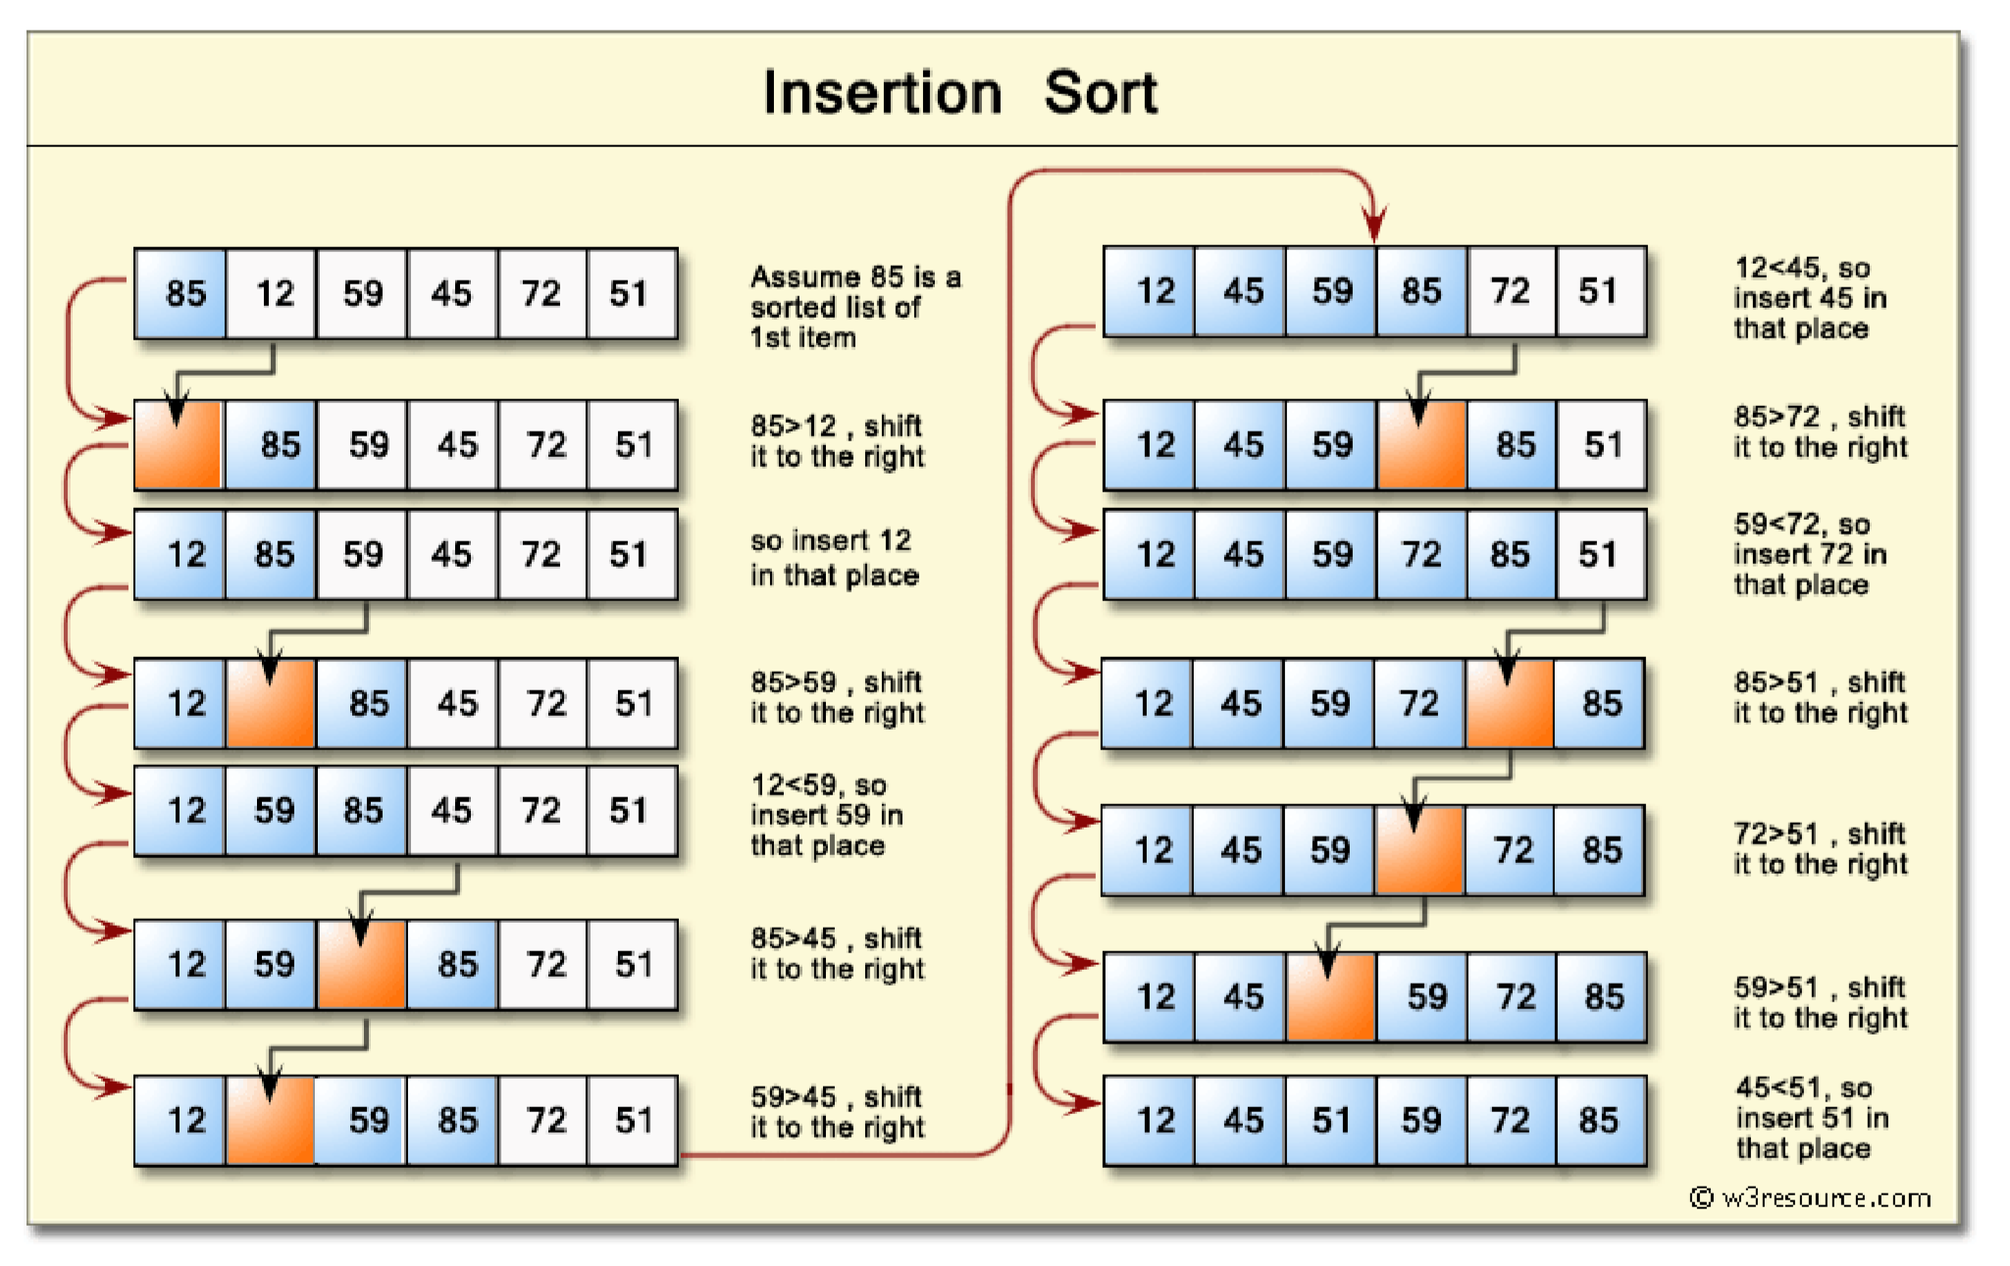

Source: <https://www.w3resource.com/java-exercises/sorting/java-sorting-algorithm-exercise-7.php>

